This Certificate is awarded to

**Nefeli Farm**

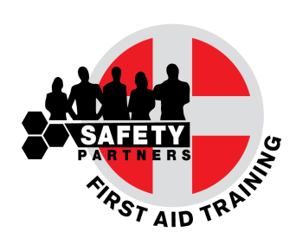

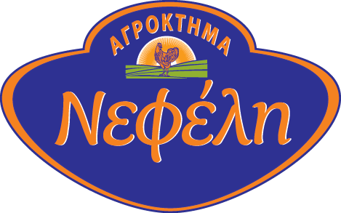

For the completion of

**First Aid at Work Training Course**

which has taken place in June 2017, in cooperation with

1. **S. Safety Partners Ltd**

*This course took place in accordance with the provisions of the Safety and Health at Work Laws*

*(First Aid) ΚΔΠ 198/2009*

___________________________

Antonis Siamailas

Director

Safety Partners is an approved First Aid at Work Training Provider by the Cyprus Republic Ministry of Labour Inspection.

Company Approval Certificate No.: 21.1.6.3.32.26/2016. First Aid Scientific Support by Nuco Training UK